

To: Professor Alan Pisano

From: Jessica Cadreau, Jennifer Fong, Cameron Graves, Makenna Hart, Steven Li

Team: Sweet Grid: Team 20

Date: 4/4/17

Subject: The SWEET City Functional Deliverable Test Report

1. **Project Objective**
   1. SWEET City is a Boston themed interactive educational exhibit made for National Grid and their customers. The main objective is to educate the public on the importance of renewable energies as well as using energy efficiently. The project satisfies these objectives using four modules: Solar, Wind, Energy Efficiency, and Smart Grid.
   2. The solar and wind modules generate power using a light source and fans, respectively. Each of these modules includes a visual that dims or brightens based on the intensity of the renewable resource. The amount of power generated is displayed on an LCD screen specific to the module.
   3. The energy efficiency module focuses on differences in energy consumption. By switching between incandescent and LED lights, National Grid customers can see the major energy benefit in retrofitting their homes with LED light bulbs. The module’s display shows power consumption of the load at the time.
   4. The final module simulates National Grid’s pilot Smart Grid program. The main objective of this module is to show National Grid’s progress in blackout response. The current black out protocol can take hours to restore power to customers. With their new pilot Smart Grid, National Grid quickly reroutes power, allowing most customers to regain power while they manually fix the cause of the blackout.

**2.0 Test Objective and Significance**

2.1 The functional testing objective was to demonstrate a working version of the SWEET City. Although the physical model is not fully arranged, the project circuitry and software are fully functional with only a few minor bugs. Functional testing gives proof that everything works correctly. There has been progress on the printed circuit board layout, and the boards should be mounted in the next few days. If there are any issues with the PCBs, the team is able to refer back to the working breadboards.

2.2 **Energy Efficiency Module**

2.2.1 The objective in testing the energy efficiency module is to show completion of one fourth of the project. This circuit has more Smart Grid applicable elements than the previous solar and wind modules. Having the circuit work successfully on a breadboard allows gives a back up if there any issues with the module’s printed circuit board.

2.3 **EE Simulation and Display**

2.3.1 The objective of testing the simulation and display is to understand the basics for programming the circuit to do specific actions and displaying data. Each module requires specific data to be displayed. The energy efficiency display is very similar to the other three modules. Displaying the power consumption for this module is helpful for other module data displays.

2.4 **Solar Module**

2.4.1 The solar module demonstrates renewable energy generation with a lamp and solar panels. Light filters held in a “jeweler’s glass” arrangement allow the user to vary solar generation. Changing the light filters simulates different weather patterns and varying times of day. A visual load will change brightness when the filters are changed.

2.5 **Wind Module**

2.5.1 The wind module also demonstrates renewable energy generation. The current setup utilizes two hair dryers to spin a 3D printed wind turbine. The turbine produces DC power with a generator. Varying the wind speed will dim and brighten the included visual load. Due to the high cut in speed of the turbine, the design will be changed to a rotary encoder and microcontroller power simulation rather than continuing with the DC generator.

2.6 **Data Acquisition - Wind and Solar**

2.6.1 The objective of testing the data acquisition is to make sure the raspberry pi correctly measures voltage and calculates current from the given load line. Once the voltage and current data is acquired, power generation can be calculated and this data is displayed on the module’s LCD.

2.7 **Smart Grid Module**

2.7.1 The Smart Grid Module reflects National Grid’s pilot smart grid program. It consists of a grid split into quadrants that contain LED lit buildings in a model of Boston. Originally, the buildings are lit and the grid has no issues. A National Grid Customer can then create a “fault point” by opening the circuit at a transmission line. Once the fault point is created, the grid will go into a blackout. After a set time interval, the grid will reroute power and come back on slowly. An LCD display shows the time it takes to reroute power and fully restore the grid.

**3.0 Equipment and Setup**

3.1 **Overall Arrangement - Energy Efficiency Module**

3.1.1 Figures 1, 2, and 3 show the three modes of circuit: both loads off, incandescent bulb lit, and LED lit, respectively. The circuit utilizes two push button switches, a P type mosfet, and an NPN BJT to power the two loads.

The first switch, S1, is a universal on off switch. When S1 is pressed, the voltage source is connected to the rest of the circuit. With S2 off, the gate of the P type mosfet (Q1) is off. This turns the mosfet on and the incandescent load is lit. When S2 is pressed, the gate of Q1 goes high, shutting off the mosfet and the incandescent load. At the same time, a base voltage is applied to Q2, turning on the NPN transistor. This lights the LED load. If S2 is released, the circuit switches back to the incandescent load. If S1 is opened at any time, the entire circuit shuts off.

Also included in the module design is a Raspberry Pi 3 and an LCD screen. When the push button switches are pushed, a voltage is also applied to a pin of the Raspberry Pi. Depending on the pin input, the the Raspberry Pi will display either incandescent or LED power consumption on the LCD. If neither button is pressed, the display shows a power consumption of zero watts.

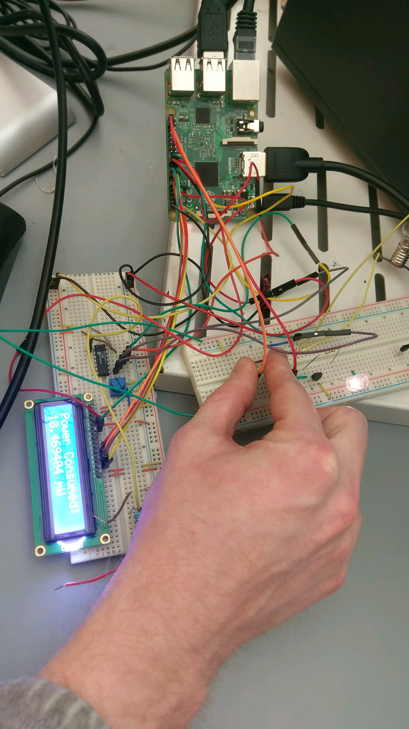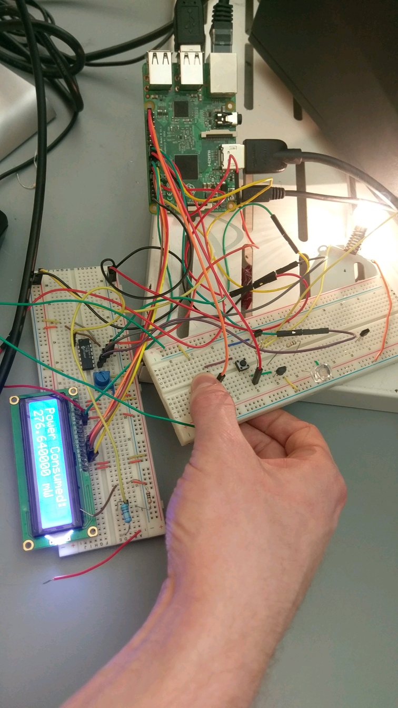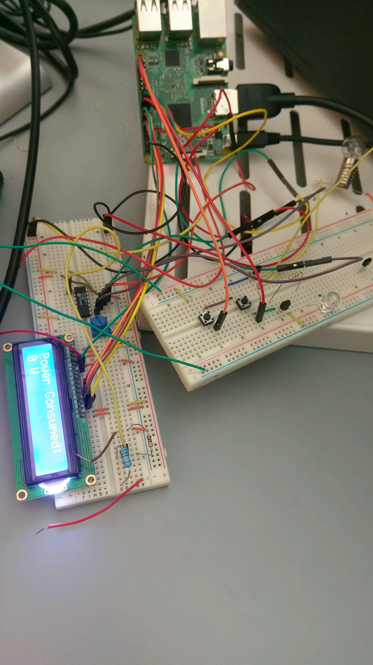

3.2 **EE Simulation and Display**

3.2.1 There are multiple components needed for this module to function appropriately. An LCD screen is used as the main display of power consumption. To set this up, the screen is connected to a breadboard. The necessary pins from the LCD are connected to the corresponding pins on the Raspberry Pi. With the LCD setup, the GPIO pins of the Pi are used to check which push buttons are being pressed. This is done with the help of some GPIO setup inside the python code which is the last necessary component.

In the code there are sections that prepare the LCD displays as well as turns the specified GPIO pins as input pins. A section is created for the variables that will contain the voltages, currents, and the power values for the two possible outcomes of our circuit. Finally, a loop is used that will continuously send the values to the LCD depending on which input pins are triggered. This loop will wait for a specified delay period before clearing the display and show a new message.

3.3 **Overall Arrangement - Solar Module**

3.3.1 As shown in figures 4 and 5, the solar module includes two solar panels, a 60W light, a raspberry pi for data acquisition, and circuit that powers an LED strip while also stepping down voltage. The included 60W light powers two solar panels in series. The solar panels power a voltage divider and an LED circuit. A voltage divider is required to step down solar panel voltage to be read by the raspberry pi. In parallel with the voltage divider, a 1kΩ resistor limits current to a strip of LEDs. The LEDs are attached to a small scale model of the “Rainbow Swash” natural gas storage tower in Dorchester.

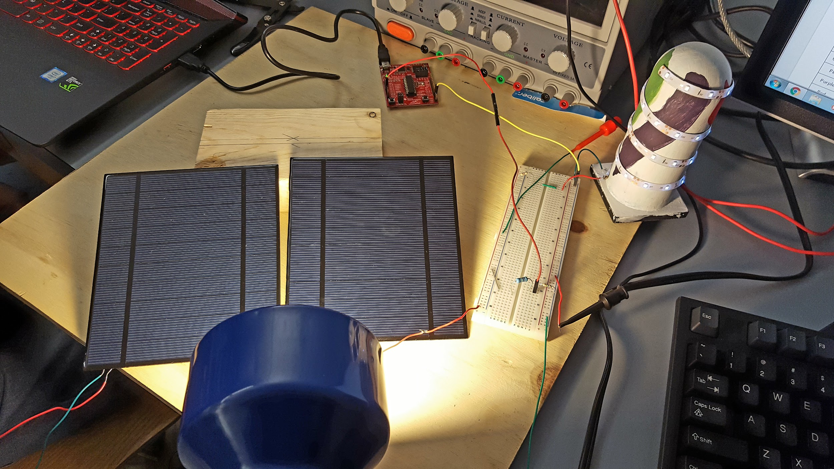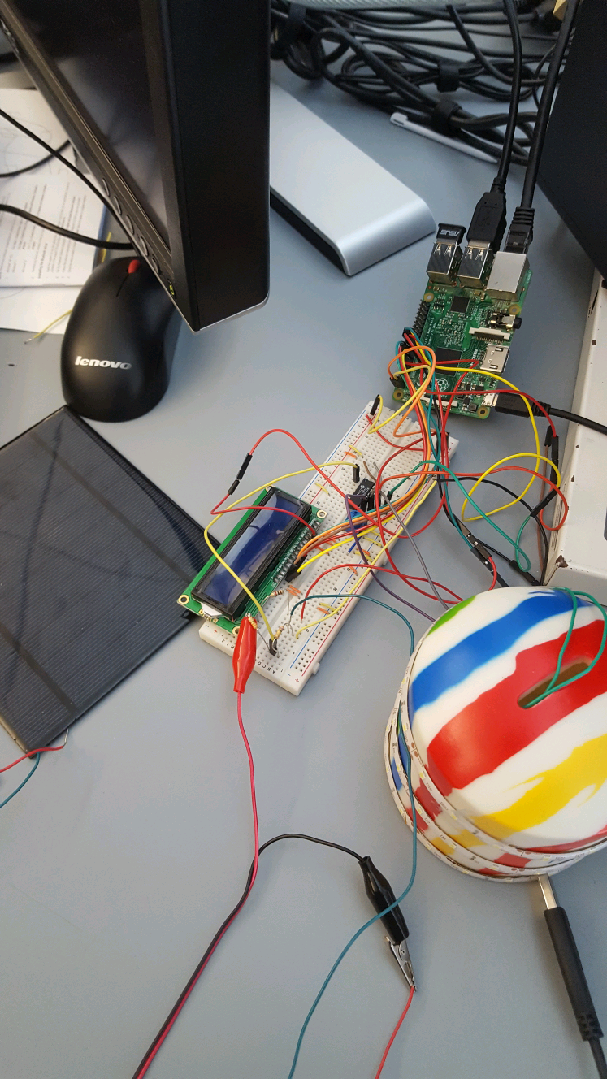

3.4 **Overall Arrangement - Wind Module**

3.4.1 As shown in figure 6, the wind modules features a wind turbine that produces DC power using a 12V DC generator. The output voltage of the generator is not high enough to power the Citgo Sign visual load. To compensate for this, an inverting operational amplifier is used to step the voltage up to usable levels. This setup is shown in figure 7.

The positive lead of the generator is connected to the inverting terminal of a TL081 op amp and the negative lead is connected to ground. The output of the op amp is connected to the LED load as well as a voltage divider. The voltage divider is used to step down the output voltage to safe levels for the raspberry pi microcontroller.

Voltage is measured and scaled from the stepped down voltage. Current is calculated from the load line equation of the LEDs and current limiting resistors. From these values, power is calculated and displayed on the LCD screen included in the module.

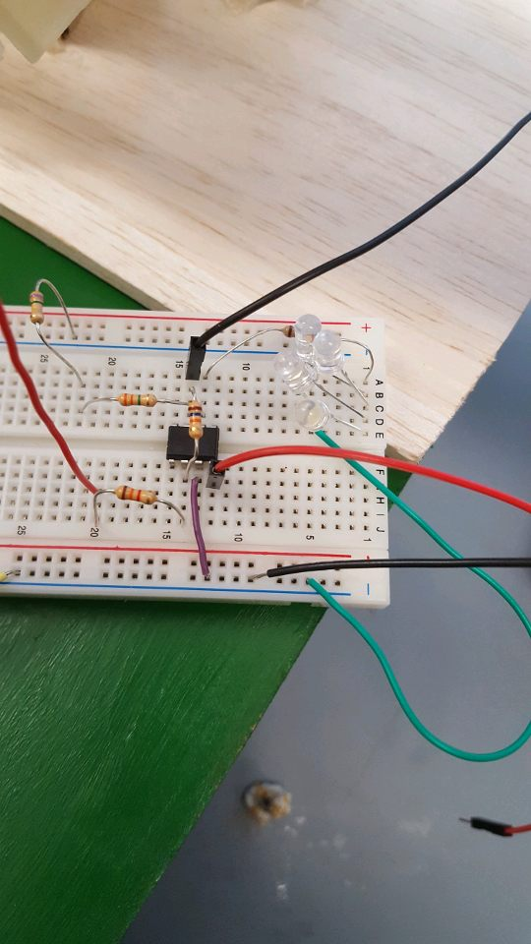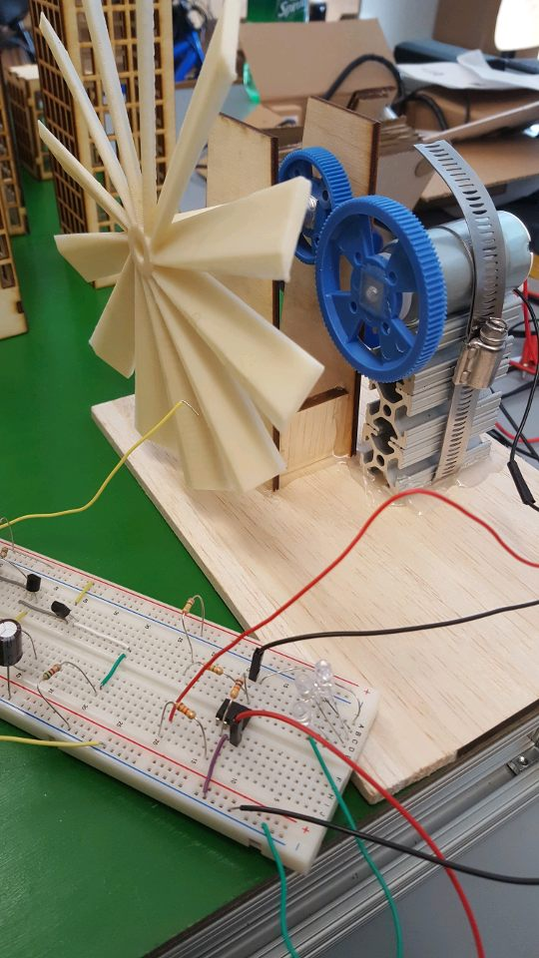

3.5 **Overall Arrangement - Smart Grid Module**

3.5.1 The smart grid module is set up in grid with 4 quadrants. Each quadrant has its own voltage source and LEDs that light buildings. The LEDs are set up in a parallel arrangement and each contain a current limiting 100Ω resistor.

A transmission line can be separated, triggering a blackout. When a blackout occurs, all four voltage sources shut down and three come back on after power is rerouted. The fourth is manually fixed by the user.

The smart grid module holds an overall display of the exhibit and allows the user to see city statistics such as “green percentage,” renewable contribution, and an overall summary of the project. This display also includes data specific to the module. The circuit setup and display are shown in figure 8.

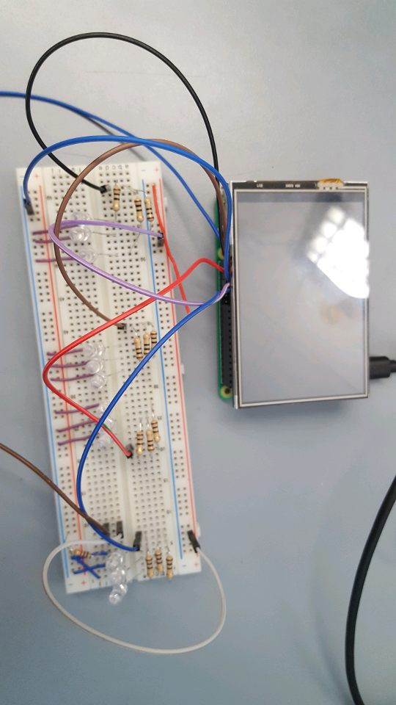

**4.0 Measurements and Data**

4.1 **Energy Efficiency Module**

4.1.1 The energy efficiency data includes brightnesses of each visual load and power consumption differences. Using an 8V source, at equal brightnesses, the LED consumed 26 times less power than the incandescent bulb. (P Led = 10.47mW, P incandescent = 276.6 mW.) Unfortunately, the incandescent bulb drew ~200 mA of current, which is outside our safety specifications. The current can be limited by changing resistor values, but this will also change the brightness of the bulb.

4.2 **Simulation and Display**

4.2.1 For testing the simulation and display, the data that was collected was whether or not the correct value was displayed based on which push button was pressed. If the universal on-off switch was pressed, the LCD would display the previously calculated power consumption of the incandescent light bulb. If both the universal switch and the second button was pressed, the LCD would display the previously calculated power consumption of the LED. When neither button is pressed the LCD would display that no power was being consumed.

4.3 **Solar Module**

4.3.1 For testing the solar module, the lights on the LNG tank would dim based on what filter was placed in front of the light. The power generated by the solar panels with the different filters is also displayed on the LCD displays.

4.4 **Wind Module**

4.4.1 Testing the wind module consisted of the turbine spinning when two hairdryers blew air at it. This would spin the generator and generate some output. That output would be stepped up so the load would light. Currently the load is just a few LEDs, but in the future a Citgo sign will be made. Similar to the solar module, the LCD would display the power generated by the wind turbine.

4.5 **Data Acquisition - Solar and Wind**

4.5.1 Testing data acquisition of the solar and wind module consists of the value of power generated changing when the filters or wind speed changed. Voltage is measured using a stepped down output voltage read by an ADC. The value is then scaled back to its original version. The current is calculated by the equation of the load line found through multiple data points found in testing. The power output is calculated by multiplying the current and voltage values.

**5.0 Conclusions**

5.1 **Energy Efficiency Module**

5.1.1 For the energy efficiency module, success is measured in terms of the correct light bulbs turning on when the corresponding buttons are pressed.

The circuit testing was deemed successful because:

* Incandescent bulb was lit and LED was not lit when switch 1 was pressed
* LED was lit and incandescent was not when switches 1 and 2 were pressed

5.2 **Simulation and Display**

5.2.1 For the simulation and display, the test is successful if the correct calculated value of power consumption is displayed when the corresponding buttons are pressed. These values were calculated by the Raspberry Pi and were confirmed using a multimeter. The simulation and display was successful.

5.3  **Solar Module**

5.3.1 The success of the solar module is measured in terms of light filters actively changing the LED brightness and power output from the solar panels. The visual load noticeably changed with different light filters, showing the module testing is successful.

5.4 **Wind Module**

5.4.1 The wind module was mostly successful, but a few changes need to be made. Changes in wind speed dimmed and brightened the LED load, but a high power input was required to receive a low power output. The module required two hair dryers to spin the turbine blades. To fix this problem, the team will move away from the 12V DC generator which is currently being used. Instead, a smaller generator or a rotary encoder will be used. This will allow for easier rotation of the turbine blades.

5.5 **Data Acquisition - Solar and Wind**

5.5.1 For the data acquisition, the test is successful if the values change based on what filters are placed in front of the light shining over the solar panels or the speed of the wind given to the turbine. The power output of both modules was displayed on screen. There were a few bugs with the solar output when no light was reaching the solar panels. Some debouncing and troubleshooting should fix this problem.

5.6 **Smart Grid Module**

5.6.1 The Smart Grid module successfully blacked out when the transmission line was removed. Three of the four quadrants came back on in the set time interval and the fourth lit when the user manually reconnected the circuit, as planned. The blackout timer did not work correctly and still needs to be implemented in the final design. Aside from the blackout timer, only the aesthetics and a bug in the display need to be corrected.

5.7 **Summary and Future Plans**

5.3.1 Overall, the functional testing was a success. Separately, all of the modules work well and the needed changes are mostly just minor improvements. As stated earlier, the wind module will undergo a major change. First, a generator with lower required torque will be used. If that does not generate more power, a rotary encoder will be used to simulate power generated by the turbine.

There will be a few other changes to the Smart Grid module. The filter for this module needs to be more aesthetically pleasing and there is also a bug in the LCD screen. The LCD should change based on the data from the other modules and the blackout timer will be fixed so it times the length of the blackout.

5.3.2 To finish this project, all of the buildings and models of Boston landmarks need to be mounted. This will allow the buildings and landmarks to be correctly wired. The PCBs will be hooked up and everything will be placed on the box. After physical placement and the adjustments to the filter, wind turbine, and Smart Grid LCD are made, the project will be finished.